Amazing Race @ Rainbow Island

Human Beings & Animals have circulatory system…
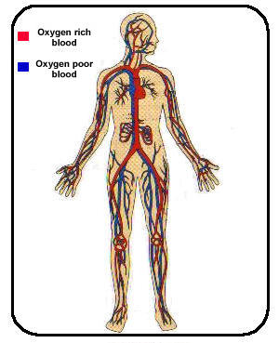  Human being’s circulatory system | 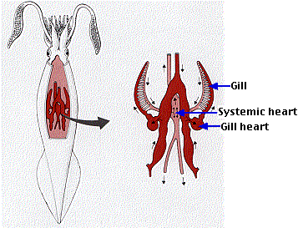  Octopus’s circulatory system | 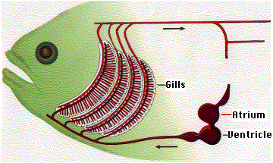  Even fish has one

How about Plants?

Amazing Race @ Rainbow Island

Objective of the game: Your group will find out how the plant circulatory system works and using materials provided make a simple but creative model of the plant circulatory system and do a presentation to the class. The presentation will be judged on clarity, creativity and teamwork. Your group’s explanation must be simple and clear so that everyone can understand.

Task information:
- You should have bought all the materials by now.
- Together with the information in the next page, your group has design a simple model showing the structure of the plant’s circulatory system.
- The model should show the plant’s xylem and phloem tubes. It should be in 3D form.
- The presentation should have information on the location of xylem and phloem tube and their function.
- You will only be given 30 Minutes to complete. After the given time limit, you have to stop whatever you are doing. Group presentation : 5 min per group
- If you need some help on how to build the model, you can approach BT Zhiyong for 1 clue. However, 20 points will be deducted away from your group.
- Maximum scores = 500 points (200 on Creativity, 200 on Teamwork and 100 on Clarity)

DURATION:

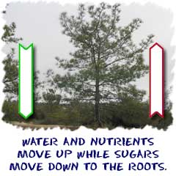
PLANTS CIRCULATORY SYSTEMS

Xylem and phloem make up the big transportation system of circulatory system of plants. It all starts with a top and a bottom. Logically, it makes sense. Trees and other plants have a top and a bottom. The top has a trunk, branches, leaves, or fruits. The bottom is a system of roots. Each needs the other to survive. The roots hold the plant steady and grab moisture and nutrients from the soil. The top is in the light, conducting photosynthesis to make food. You have to connect the two parts. That's where xylem and phloem come in.

XYLEM TUBE
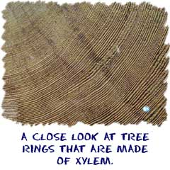
The xylem tubes of a plant are the system of tubes and transport cells that circulate water and dissolved minerals. As a plant, you have roots to help you absorb water. If your leaves need water and they are 100 feet above the ground, it is time to put the xylem into action! Xylem is made of vessels that are connected end to end for the maximum speed to move water around. Xylem tube transports water and minerals from the roots to the other parts of the plants. When someone cuts an old tree down, they reveal a set of rings. Those rings are the remains of old xylem tissue, one ring for every year the tree was alive.

PHLOEM FUN
The fun never stops in the plant's circulatory system. Most plants have green leaves, where the photosynthesis happens. When those sugars are made, they need to be given to every cell in the plant for energy. Thus the phloem cells come in. The phloem cells are laid out end-to-end throughout the entire plant. The phloem tube transports food created by the leaves to the other parts of the plant. Phloem is always alive. Xylem tissue dies after one year and then develops anew (rings in the tree trunk). What is the best way to think about phloem? Think about sap coming out of a tree. That dripping sap usually comes from the phloem.

If you don’t understand any of the information given, you can approach any Buddy Tutor for help☺

~END~

