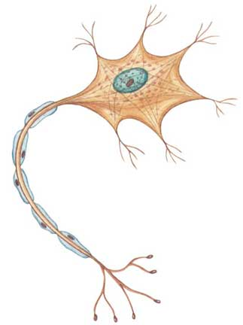  What is this? | 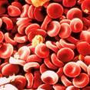  What is this? | 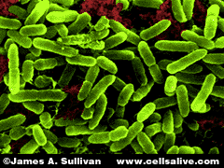  What is this?
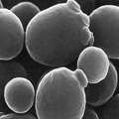  What is this? | 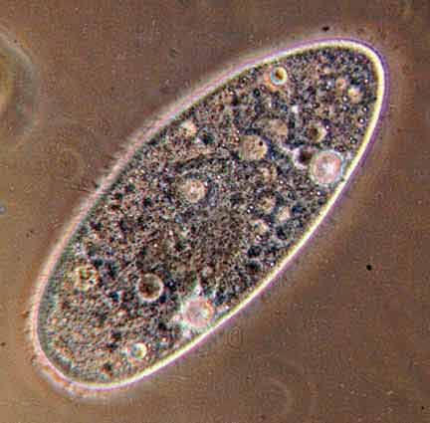  What is this? | 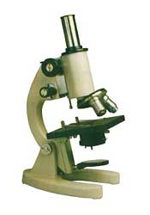  Name the instrument. Why is there a need for it?

Soil Bacterial | Red Blood Cells: Cells that are in our blood. It is red in colour.  Extra Information:  Red blood cells do not have nucleus. Since red blood cells carry oxygen around our body in the thin blood vessels. It will be easier for them to “throw away” the nucleus so that it is easier for them to pass through the thin blood vessels. | Nerve cell: This is a nerve cell in our brain. It carries information from one nerve cell to another.
Microscope.  Cells are so small that we cannot see them using our naked eyes. Thus, the microscope is used to magnify it to thousands of times. This will enable us to see the cells. | Paramecium:  Paramecium is a single-cell organism.  It is common in ponds throughout the world. This tiny living creature has all the systems required for survival packed into a single cell! | Yeast: single – cell organism  Used in making the dough rise. Without it the bread you eat will be very hard and flat.  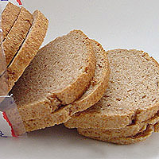

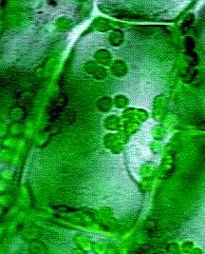  Guess what is this? How do you know? | 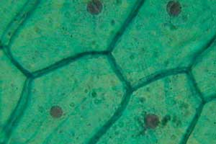  Name 6 parts of a plant cell | Guess what is this? (green “dots”)
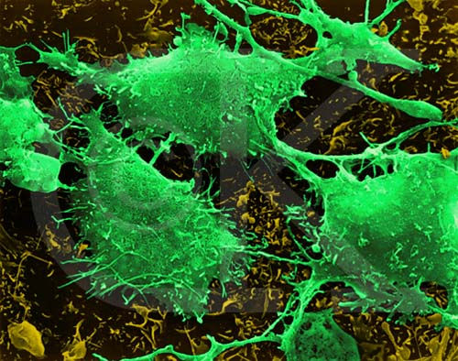  What is this? | 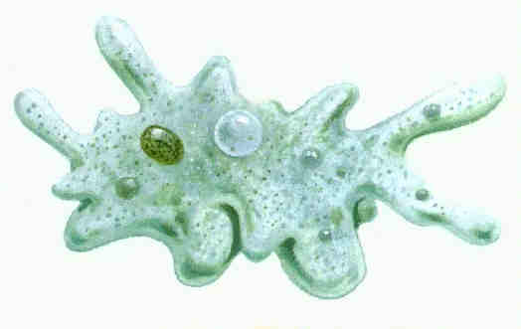  What is this? | 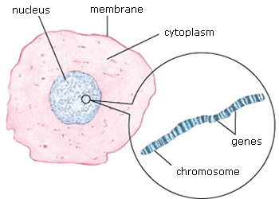  Guess what is this? What is it make up of?

Chloroplasts:  Tiny green structures found in the cytoplasm of a plant cell. Chloroplasts contain chlorophyll, the pigment that captures sunlight to make food for the plant. Chloroplast is not present in animal cells. | Nucleus, cell membrane, cytoplasm, cell wall, chloroplasts, sap | Plant Cell.  Plant cell is generally rectangular in shape unlike animal cell which is generally round in shape.
Animal cell.  It is made up of nucleus, cell membrane and cytoplasm. | Amoeba  Amoeba is one example of single-cell organism. Amoeba is found in freshwater, typically on decaying vegetation from streams, also found in salt water and wet soil. | Brain cancer cell

What is a nucleus? | 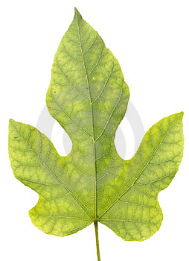  Can you find chloroplast in an animal cell? What is inside the chloroplast? What is the use of chlorophyll? | Name 3 similarities between animal and plant cells.
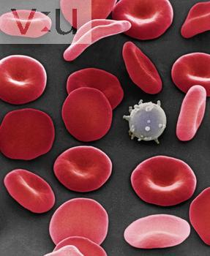  Guess what is this white stuff? | What gives a plant cell its  shape? | What are 3 parts of a plant cell that cannot be found in an animal cell?

Both have cytoplasm, cell membrane and nucleus. | No.  Chlorophyll  Chlorophyll captures sunlight to make food for the plant. | Nucleus:  Nucleus acts like the brain of the cell.  In both plant and animal cells, there is a nucleus found in the cytoplasm. The nucleus is a very important part of a cell. It helps control everything that happens inside the cell.
Cell wall & Chloroplasts | Cell wall:  Cell wall is made up of a stiff material that gives a plant its shape. | White blood cell:  One of the cells the body makes to help fight bacteria.

